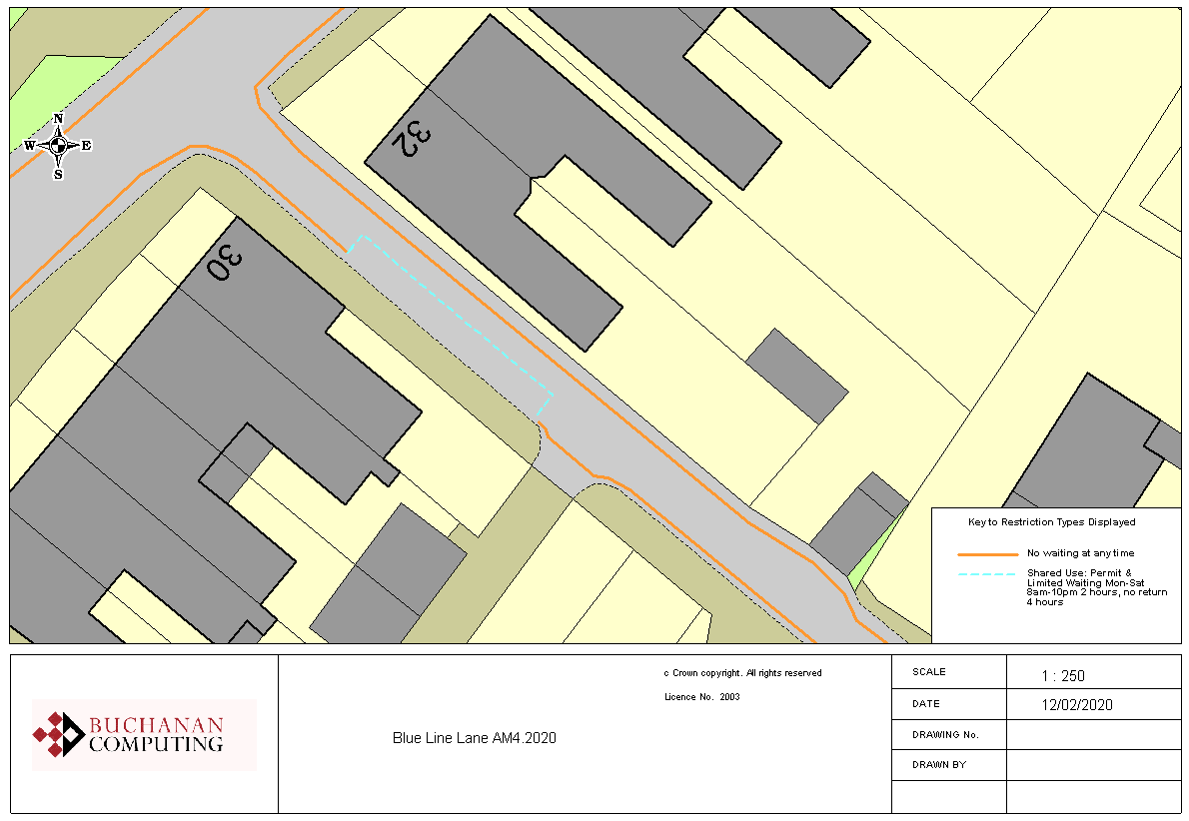

Existing no waiting at any time restrictions

Existing shared use parking bays

**N.B. No change to restrictions as they appear on the ground**

**Key:**

**Location:**

**Blue Line Lane, Ashford**

**Proposed Order:**

The Kent County Council (Various Roads, Borough of Ashford) (Waiting Restrictions and Street Parking Places) Amendment 4 Order 2020

**Amendment 4 2020**

**Proposed changes**