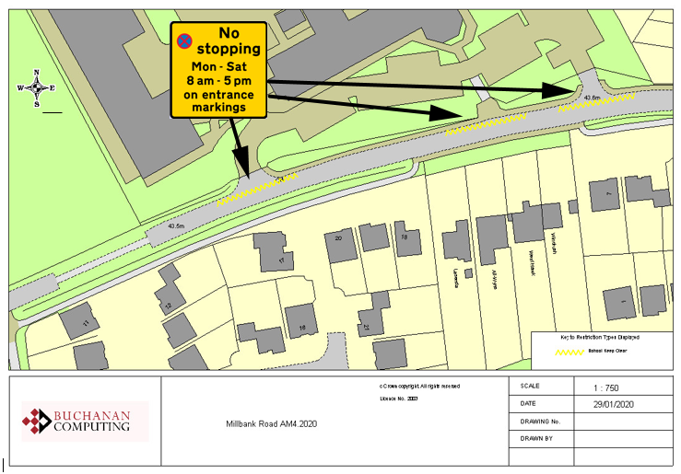



Existing school entrance markings

**NB No change to restrictions as they appear on the ground**

**Key:**

**Location:**

**Millbank Road, Ashford**

**Proposed Order:**

The Kent County Council (Various Roads, Borough of Ashford) (Waiting Restrictions and Street Parking Places) Amendment 4 Order 2020

**Amendment 4 2020**

**Proposed changes**