Statement by David Reece
My name is David Reece. I have been a houseowner in Wye since 1972. Although I have no connections with Wye College, my family and I have been privileged to enjoy the College facilities in many different ways.
I have used the gym, played squash in the old squash court, and tennis at the Withersdane courts. For these activities there was meant to be a nominal charge, but the College never tried too hard to collect it.
There were no restrictions on walking over the College land. I am familiar with every footpath, and I have rough shot in the remoter areas with members of staff. I have impressed visitors by showing them the lovely memorial gardens at Withersdane. I remember an amazing Midsummer Night’s Dream performance under the massive old mulberry tree in the Withersdane grounds.
Quite apart from the educational function which brought life and fun from the students, many from Commonwealth countries, the College buildings are seen as an important element of Wye’s history and heritage: both visually at the core of the mediaeval centre, and because residents have been accustomed over the years to go to meetings and attend functions in one or other of the communal spaces. I particularly remember going to various auctions and sales in the Wolfson House lecture theatre, and to dances in the enormous Swanley Hall. Looking back, it was as normal to attend a meeting in one of the College rooms as in any other public room in the village.
Perhaps the most striking for me were a couple of black-tie dinners in the Parlour, where the atmosphere of intimacy and a connection with years gone by in this small, oak-panelled room was relished by all.
The single most important event for my family was the wedding reception held in the College buildings after my daughter’s marriage in the adjacent Wye Church on 15 June 2002. The guests assembled and admired the interior of this large and ancient country church. They might have continued to admire it for quite a while, but to the relief of the groom, the football-mad vicar and the ushers were not delayed by a threatened penalty shoot-out of the World Cup semi-final.
After the ceremony it was just a short stroll before entering the gate by the Latin School. Champagne circulated in the Latin School garden while the photographer worked away.
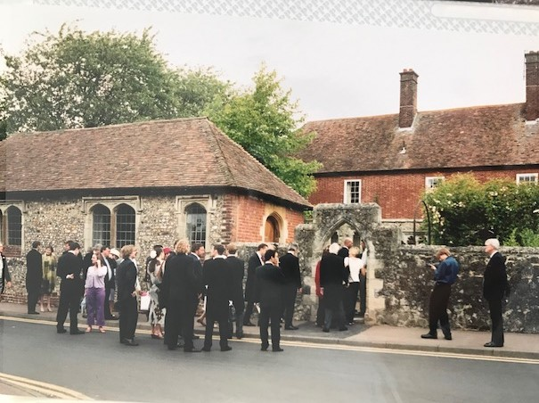

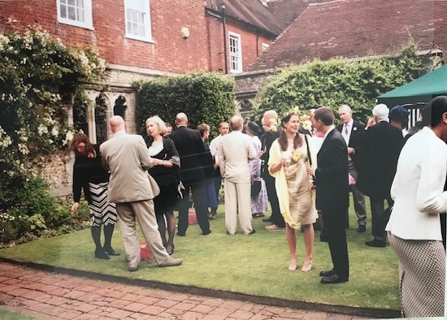
The wedding party then took up position in the Cloisters to greet the guests. One young man made my day even more special by commenting on what a nice house I had, and I don’t think I corrected him.
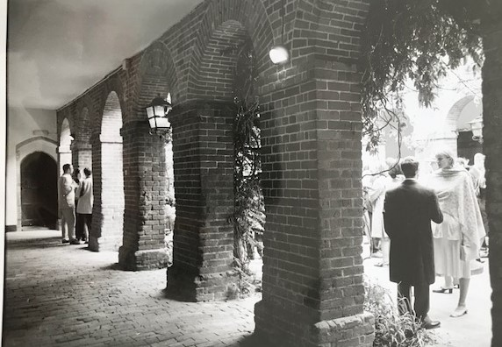

Quite a considerable time later we all assembled in the Dining Hall which had been beautifully decorated.
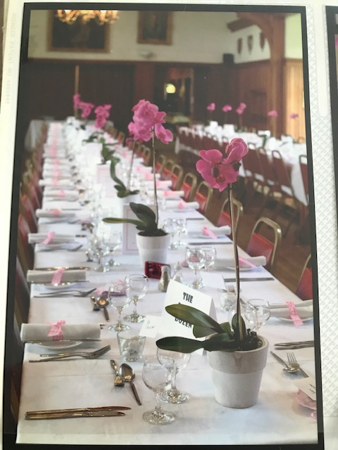
There were about 160 at the reception dinner, full capacity for the venue, and the staff did a great job in serving these numbers without the food getting cold. From the video it looks like I seem to have made a speech, with others.
The rest of the evening was spent between the Dining Hall and a marquee erected in the Main Quad with live music and a well-used bar. Finally, the happy couple were seen off the premises in a sparkler parade. Charlotte fulfilled what was apparently a life-long dream of running barefoot through the village to their room in the Wife of Bath.
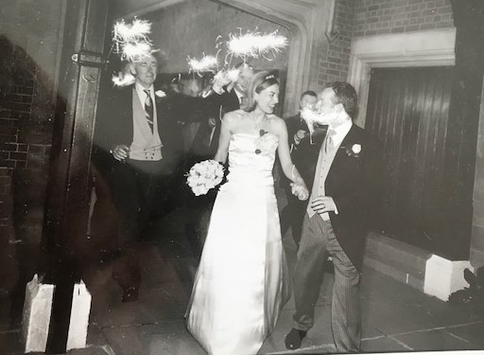
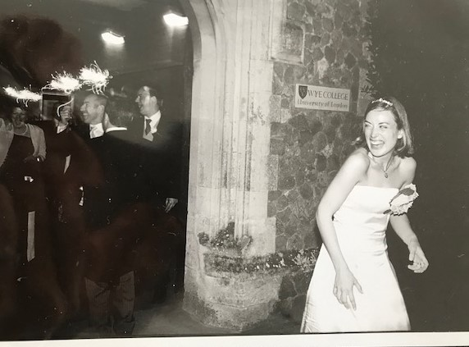

There was no doubt from the letters afterwards what a lovely day had been had by all, with the College facilities playing a full part in making it truly memorable.

