**Location:**

**Cornes Close, Ashford**

**Proposed Order:**

The Kent County Council (Various Roads, Borough of Ashford) (Waiting Restrictions and Street Parking Places) Amendment 4 Order 2020

**Amendment 4 2020**

**Proposed changes**

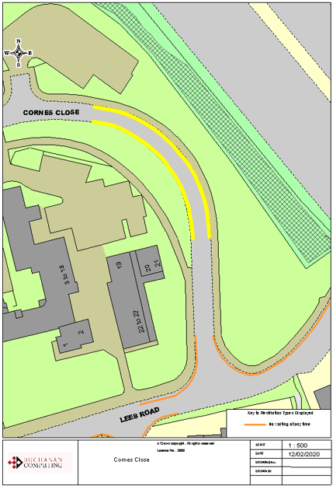

**Key:**

Existing no waiting at any time restrictions (Double yellow lines)

**Proposed** no waiting at any time restrictions

(Double yellow lines)