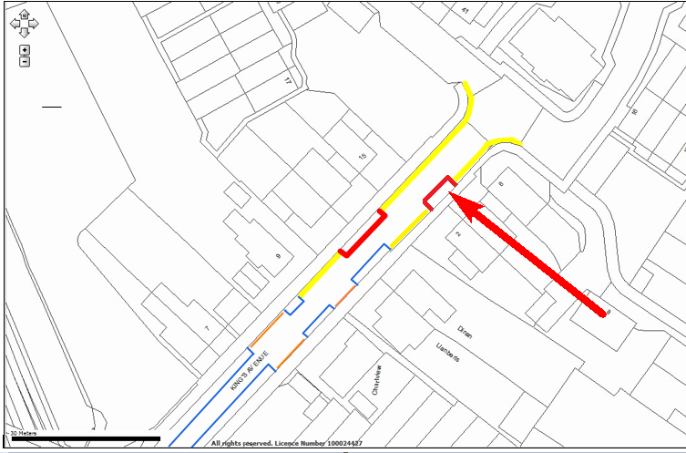

**Location:**

**Kings Avenue, Ashford**

**Proposed Order:**

The Kent County Council (Various Roads, Borough of Ashford) (Waiting Restrictions and Street Parking Places) Amendment 4 Order 2020

**Amendment 4, 2020**

**Proposed changes**

**Key:**

|  |  |
| --- | --- |
|  | Amended no waiting at any time restrictions (double yellow lines) |
|  | **Existing** no waiting at any time restrictions (double yellow lines) |
|  | **Existing** shared use parking bays Permit and limited waiting  Mon-Sat 8am-10pm hours, No return to zone within 4 hours |
|  | Amended shared use parking bays Permit and limited waiting  Mon-Sat 8am-10pm hours, No return to zone within 4 hours |