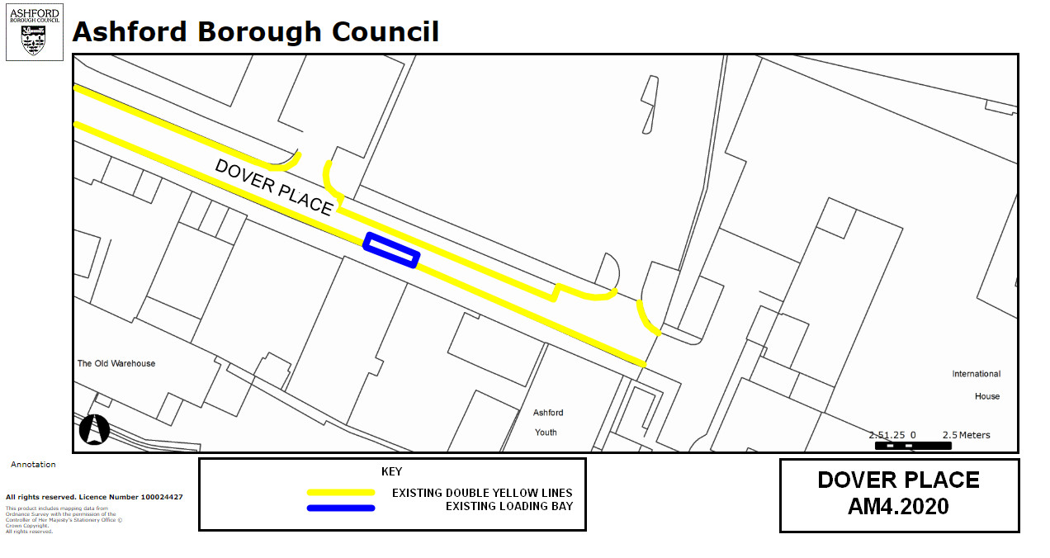

**Key:**

**Existing** no waiting at any time restrictions

(Double yellow lines)

**Existing** Loading Bay

**NB No change to restrictions as they appear on the ground**

**Amendment 4, 2020**

**Proposed changes**

**Location:**

**Dover Place, Ashford**

**Proposed Order:**

The Kent County Council (Various Roads, Borough of Ashford) (Waiting Restrictions and Street Parking Places) Amendment 4 Order 2020