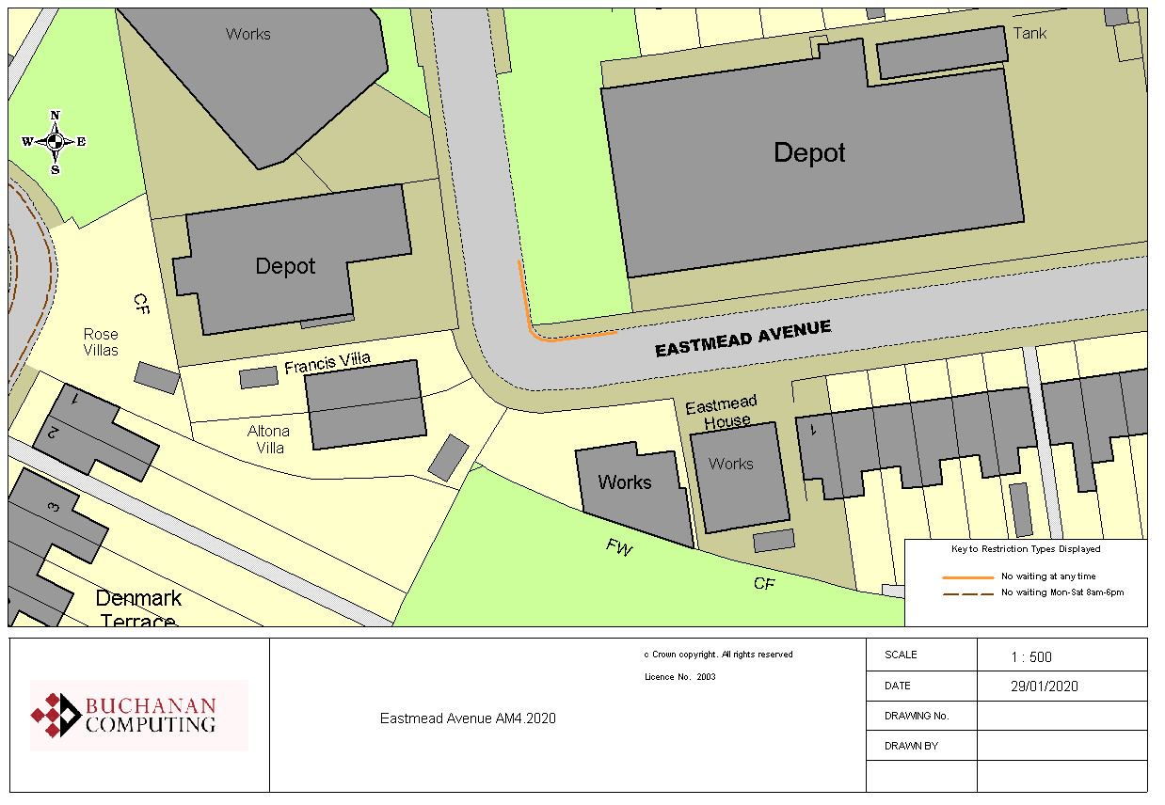

Proposed no waiting at any time restrictions
Key:
Location:
Eastmead Avenue, Ashford
Proposed Order:

The Kent County Council (Various Roads, Borough of Ashford) (Waiting Restrictions and Street Parking Places) Amendment 4 Order 2020
Amendment 4 2020

Proposed changes

In the Borough of Ashford

THE KENT COUNTY COUNCIL (VARIOUS ROADS, BOROUGH OF ASHFORD)

(WAITING RESTRICTIONS AND STREET PARKING PLACES)

(AMENDMENT 1) ORDER 2016

NOTICE is hereby given that the Kent County Council acting as local traffic authority and in exercise of its powers under sections 1(1), 2(1) to (3), 3(2), 4(1) to (3), 32(1), 35(1), 45, 46, 49, 53 and 124 and Part IV of Schedule 9 to the Road Traffic Regulation Act 1984 and of all other enabling powers, intends to make the above Order, the effect of which will be to amend ‘The Kent County Council (Various Roads, Borough of Ashford) (Waiting Restrictions and Street Parking Places) Consolidation Order 2016’ (as amended), the effect of which will be:

In the Town of Ashford
Street | Proposed Changes
Adams Drive | Introduction of double yellow lines at its junctions with Billington Grove and Rayworth Court
Austin Road (section accessed from Wotton Road) | Introduction of restricted parking zone with overnight & weekend HGV parking ban
Billington Grove | Introduction of double yellow lines at its northern junction with Adams Drive
Ellingham Way | Introduction of restricted parking zone with overnight & weekend HGV parking ban
Finn Farm Road | Introduction of double yellow lines on bend and at its junctions with Violet Way and Finn Farm Road (leading to Church Hill)
Hoxton Close | Introduction of double yellow lines in the vicinity of Great Chart Primary School
Rayworth Court | Introduction of double yellow lines at its junction with Adams Drive
Violet Way | Introduction of double yellow lines at its junction with Finn Farm Road
Wotton Road (Kingsnorth Industrial Estate) | Introduction of restricted parking zone with overnight & weekend HGV parking ban

In the Town of Tenterden
Street | Proposed Changes
Danemore | Extension of double yellow lines and introduction of single yellow line on western side, introduction of Ambulance only parking bay
High Street | Introduction of 3 on-street disabled persons parking bays where waiting by Blue Badge holders will be limited to 3 hours stay with no return in 1 hour
High Street | Administrative amendment to clarify existing descriptions. This does not propose any change to restrictions as they currently appear on the ground.

A copy of the proposed Order and supporting documents may be inspected on line at www.ashford.gov.uk/parkingconsultation or in hard copy format at the Civic Centre, Tannery Lane, Ashford TN23 1PL between 9am and 3.45pm Monday to Friday, and at Tenterden Town Hall, High Street, Tenterden TN30 6AN between 9am and 4pm Monday to Friday. A copy of the proposed Order will also be available at the main reception of Sessions House, Maidstone, Kent ME14 1XQ between 8am and 6pm Monday to Friday.

Any objections or other representations relating to this Order must be made in writing to: Engineering Services, Ashford Borough Council, Civic Centre, Tannery Lane, Ashford, Kent, TN23 1PL or by email to consultation@ashford.gov.uk. In order to be considered, objections must specify the grounds on which they are made.

Objections or other representations to this Order should include return address details and quote reference “2015/Am1”, but must be received by no later than midnight on Thursday 12th May 2016 in order to be considered.

