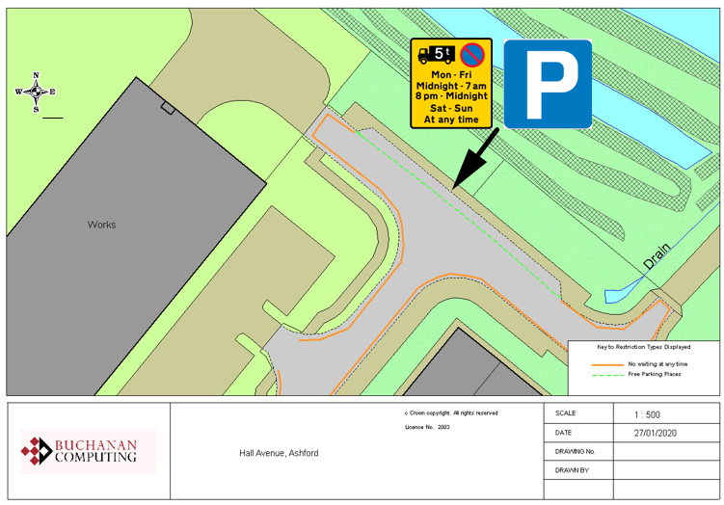

Existing no waiting at any time restrictions

Proposed parking bay

**N.B. existing overnight waiting ban (over 5t) will not be affected**

**Key:**

**Location:**

**Hall Avenue, Ashford**

**Proposed Order:**

The Kent County Council (Various Roads, Borough of Ashford) (Waiting Restrictions and Street Parking Places) Amendment 4 Order 2020

**Amendment 4 2020**

**Proposed changes**