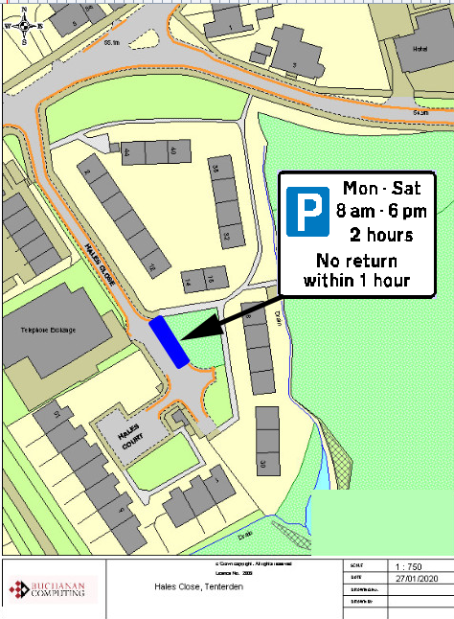

Existing no waiting at any time restrictions

Proposed parking bays (location of existing disabled bays)

**Key:**

**Location:**

**Hales Close, Tenterden**

**Proposed Order:**

The Kent County Council (Various Roads, Borough of Ashford) (Waiting Restrictions and Street Parking Places) Amendment 4 Order 2020

**Amendment 4 2020**

**Proposed changes**